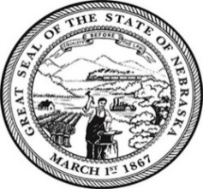
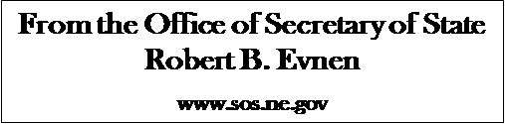

For Release:
December 13, 2019
Contact:
Cindi Allen
402-471-8408

Secretary of State rolls out a new website before the New Year

LINCOLN- Today, Secretary of State Evnen announced the roll out his new website, in time for the New Year. “The website has an updated design and is user friendly,” stated Secretary Evnen. The home page displays a photo of Chimney Rock together with a well-placed voter registration button. Users will find easy access to business searches and other business services, elections, international resources, rules and regulations, records, forms and filings. “The new look says Nebraska proud,” Evnen said. To view go to https://sos.nebraska.gov

###

