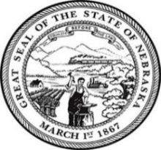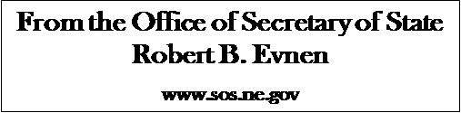

For Release:
May 7, 2020
Contact:
Cindi Allen
402-471-8408

Nebraskans are in the high numbers for the 2020 Primary Election
(Insert photo)

LINCOLN- Nebraska voters – vote - despite COVID-19. “A record number of Nebraska voters requested an early ballot this year amid a COVID-19 event,” stated Secretary of State Bob Evnen. “To date, 63.7% of those who requested early ballots have returned their ballots and 47.8% of the voters in the all-mail-in counties have returned their ballots as well.”

Voters have two options to choose from when returning an early ballot.

1. Sign and mail it
2. Sign and drop it off at the voter drop box located in your county. (Recommended)

All early ballots need to be returned by the close of polls Tuesday, May 12, using one of the two options listed above.

For more information visit https://sos.nebraska.gov/

###

