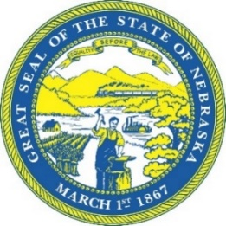
STATE OF NEBRASKA
ROBERT B. EVNEN
SECRETARY OF STATE

For Release:
December 1, 2020
Contact:
Cindi Allen
402-471-8408

Nebraska Canvas Board certifies 2020 General Election

LINCOLN- The 2020 General Election is officially in the books. Members of the Board of State Canvassers reviewed and approved the results of the statewide election. No major problems were noted in the Canvass Board review. Four NRD state races qualified for an automatic recount, however, the candidates who were behind in three of the contests waived their right to an automatic recount. A recount for Lower Platte North NRD Sub 5, where the candidates are separated by one vote, will still occur on December 2, with the results of that election to be certified during the next Canvas Board meeting December 4.
Secretary of State Bob Evnen opened with a few remarks regarding the success of the general election amid a coronavirus pandemic. “The November 3rd general election was historic in a number of respects. More Nebraskans voted in our 2020 general election in the history of our state.” Evnen added, “Nebraska polls were open, and our voters and poll workers were kept safe. This was all accomplished within the existing legal framework in our state. Nebraska voters refused to allow the coronavirus pandemic to prevent them from exercising their right to vote.”
Deputy Secretary for Elections Wayne Bena noted, “All 93 counties received new ballot counting machines and ADA-compliant ballot marking equipment this year, and Nebraska received high marks for election security.” Last year, Nebraska was awarded the Inaugural Innovators Award presented by the National Association of State Election Directors (NASED) for our state’s work in election security.
Participating as members of the Board at today’s meeting were Governor Pete Ricketts, Secretary of State Bob Evnen, State Treasurer John Murante and Auditors of Public Accounts Charlie Janssen, Chief Deputy Attorney General Dave Bydalek participated on behalf of Attorney General Doug Peterson

###

