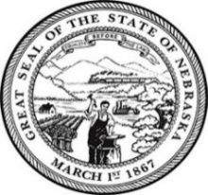
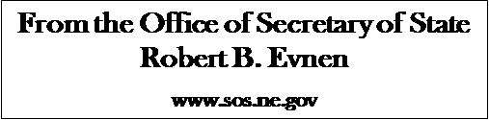

For Release:
January 16, 2020
Contact:
Cindi Allen
402-471-8408

The Epic Passage of USMCA
LINCOLN- Nebraska Secretary of State Bob Evnen today congratulated the U.S. Senate on its ratification of the United States-Mexico-Canada Agreement (USMCA), which replaces NAFTA as the new free trade agreement between the three countries.
“Our Nebraska industries, particularly agriculture, will benefit from this updated and improved free trade agreement among our three countries,” Secretary Evnen said.
The leaders of the three countries signed the United States-Mexico-Canada Agreement (USMCA) November 30, 2018. The USMCA was subject to ratification by the governments of all three countries.
December 2019, the USMCA was approved in the U.S. House of Representatives, sending the landmark trade agreement to the United States Senate. With the vote of approval today in the Senate, the United States has ratified the USMCA, which will bring the economic benefit of fairer trade to North America. Mexico ratified the agreement last year. Canada is on track to ratify the agreement very soon.
“USMCA also has immense valuable strategic value because it will serve as a guide to other future trade negotiations and agreements,” Evnen noted.
The new trade agreement replaces the 25-year-old North American Free Trade Agreement (NAFTA) that governed trade between the United States, Canada, and Mexico. The old NAFTA greatly improved the freedom of trade in North America, but the agreement did not adequately address current issues related to technology, currency manipulation, labor, the environment, and dispute settlement. Likewise, NAFTA resulted in a trade deficit for the United States, with the exception of agriculture.
Agriculture benefited from NAFTA, and was the only economic sector in which there was trade surplus. During its negotiation of USMCA, the Trump administration heeded the advice of the agricultural industry - do no harm.
The USMCA will result in the further growth of trade opportunities for agriculture and other Nebraska industries.
“The passage of USMCA is a win for agriculture and Nebraska,” stated Secretary Evnen. “I applaud our USTR chief negotiators, President Trump, and our Nebraska representatives in Washington for the historic passage of USMCA.”
###

