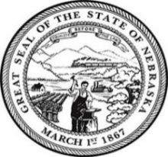
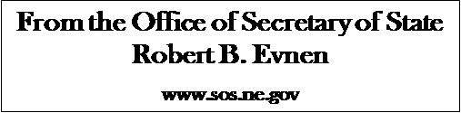

For Release:
February 4, 2020
Contact:
Cindi Allen
402-471-8408

Secretary of State Evnen – Nebraskans can be Confident in Nebraska’s Elections

LINCOLN- “Nebraskans can be confident that their primary election ballots will be counted and reported promptly and accurately,” Nebraska Secretary of State Bob Evnen said today.
Nebraska presidential primary ballots will include candidates from the Democratic, Republican and Libertarian parties. None of these parties will utilize caucuses this year in this year’s primary.
Primary election results have an impact on who party delegates support at their national conventions, where candidates for the general election are chosen.
Nebraska’s elections are secure. New ballot counting devices are being delivered and installed in every county of our state. These devices are not connected to the internet. The results are compiled in hardened computers that also are not connected to the internet. These results are then transferred to another device and uploaded to Nebraska’s election night reporting system. Nebraska’s election night reporting system is itself protected by two backup systems.
“Because of the cooperation of the unicameral and the governor, and the dedication of our county election officials and our Secretary of State Elections Division, Nebraskans can be confident that they will receive accurate and prompt election night results. It is very important for Nebraskans to register and very important for Nebraskans to vote.”
Nebraska’s primary election will be held on May 12, 2020. For more information visit https://sos.nebraska.gov/

###

