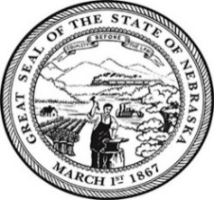
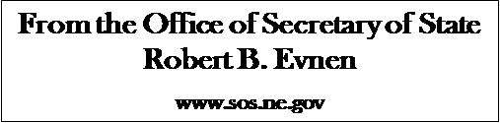

For Release:
June 10, 2019
Contact:
Cindi Allen
402-471-8408

Secretary Evnen reminds Nebraskans June 14th is National Flag Day
LINCOLN- Secretary of State Bob Evnen reminds Nebraskans to proudly fly the U.S. and Nebraska flags on National Flag Day, June 14th. Flag Day originated in 1885 to observe June 14th as the anniversary of official adoption of the stars and stripes. Enthusiastically called “Flag Birthday,” Flag Day was celebrated by school children who would assemble to be given a small Flag. “Flags are a reminder of the freedoms we enjoy as American citizens and Nebraskans” Secretary Evnen stated, “a symbol of ourselves.”
“My red stripes proclaim the fearless courage and integrity of American[s]. The white stripes stand for liberty and equality for all, the blue is the blue of heaven, loyalty and faith. I represent these eternal principles: liberty, justice, and humanity… ever known as Old Glory. Guard me well lest your freedoms perish.” – “I am the Flag” written by Ruth Apperson Rous.

The office of Secretary of State offers a free service that provides Nebraskans an opportunity to request to have a flag flown over the State Capitol. The only requirements are that a flag must be provided to the Secretary of State’s office with information about when, why, and for whom the flag should be flown.
Flags are flown Monday through Friday, with the exceptions of holidays. Each flag will be accompanied by a keepsake certificate signed by Secretary Evnen and will include the date and the purpose of the flight.
Nebraskans who wish to have a flag flown over the Capitol should call (402)471-4070, email anna.castro@nebraska.gov or go online http://www.sos.ne.gov/protocol/flag_flying.html for additional information. The Secretary reserves the right to approve all request.

###

