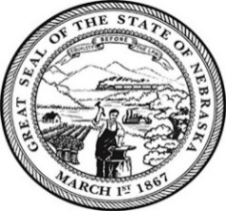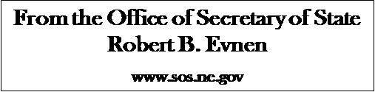

**For Release:**

November 25, 2019

**Contact:**

Cindi Allen

402-471-8408

**Secretary Evnen Kicks off Grand Opening of Douglas County Election Commission**

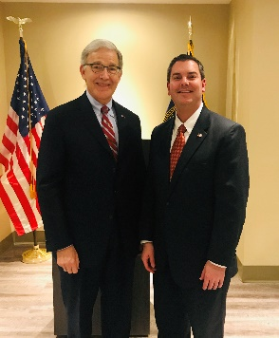

*(Secretary of State Bob Evnen and Douglas County Election Commissioner Brain Kruse)*

**LINCOLN-** On Thursday, Secretary of State Bob Evnen took part in a ribbon cutting ceremony for the new location of the Douglas County Election Commission. The new facility located at 12220 West Center Road, Omaha, underscores the commitment to Douglas County voters and the public. Customer service stations have increased from six to nine spaces. A drive up drop box located at the west end of the building is open 24 hours a day 365 days a year. Parking has also increased to 230 stalls. On Election Day, the spacious office area turns into a call center, where stations staffed with trained election workers are available to assist voters in finding their polling place, verifying their registration status, and answer any other questions.

Secretary Evnen acknowledged Brain Kruse for his work as Douglas County Election Commissioner. “Brain is doing an outstanding job in his role as Douglas County Election Commissioner,” stated Secretary Evnen. “Everyone in the Secretary of State office is busy gearing up for the 2020 elections and we appreciate the strong relationship we have with our county partners.”

For more information about elections visit [www.sos.gov](http://www.sos.gov)

###