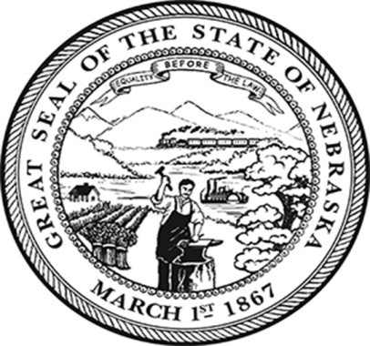
From the Office of Secretary of State
Robert B. Evnen
www.sos.ne.gov

For Release:
December 10, 2019
Contact:
Cindi Allen
402-471-8408

Candidates reminded not to use the state seal in campaigns
LINCOLN – Secretary of State Bob Evnen reminds candidates running for office in 2020 and political consultants that the use of the state seal is prohibited, for political or campaign purposes. Evnen, who is keeper of the Great Seal of Nebraska, reiterated that use of the seal was strictly limited to state government and educational use.
Anyone wishing to utilize the Great Seal must request written permission from the Secretary of State. Each request is evaluated to determine if it meets the guidelines.
“Citizens often will tell us of someone using the state seal on a website or social media page,” Evnen explained. “Occasionally, it is in connection with a campaign. Other misuses we discover are associated with a product or an organization.”
Evnen said it is a common misconception that the state seal is available for public use. Furthermore, there is only one official and correct image. “Images that are available on the internet are frequently inaccurate. So, not only could someone be using the image inappropriately, that person may not even be using the right one.”
“Using the state seal is like having a stamp of state endorsement, which is a wholly inaccurate message if being conveyed by political campaigns or product marketing,” Evnen elaborated. “As a recognized icon and honored symbol of the state, the Great Seal should be treated with integrity and respect.”
Evnen said warnings will issued to anyone who uses the seal inappropriately.
“Fortunately in recent years, we have been able to get the word out and are having better luck with people seeking written permission from my office to use the state seal,” said Evnen. “It is important that this continues to be the policy going forward.”
###

