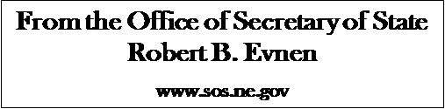

For Release:
February 5, 2020
Contact:
Cindi Allen
402-471-8408

Secretary of State Evnen Reminds Candidates of Filing Dates

LINCOLN- Secretary of State Bob Evnen said today, “The deadlines are fast approaching for incumbent and non-incumbent candidates to file for the primary election in 2020.” Incumbents are current office holders, regardless of whether the office that they currently hold is the office that they are seeking. Non-incumbents are those who currently do not hold any elective office.
“Incumbents must file by the close of business February 18, 2020; non-incumbents must file by the close of business on March 2, 2020,” Evnen said.
The Elections Division of the Secretary of State’s office is located at 1221 N Street, in downtown Lincoln. The office is located west of the Great Western Bank. Visitors should enter the main doors at Center on N and look for Suite 103 on the main floor.
An updated list of statewide candidates is posted weekly on the Secretary of State website. Other information for the May 12th primary and November 3rd general election also can be found on the Secretary of State website. https://sos.nebraska.gov/
If you need additional assistance, call the Elections Division at 402-471-2555.

###

